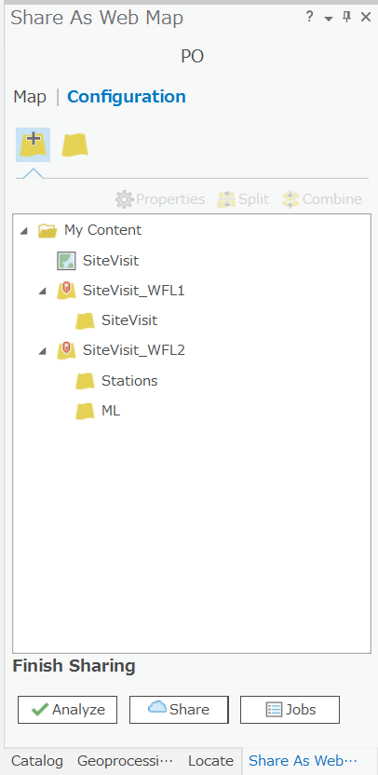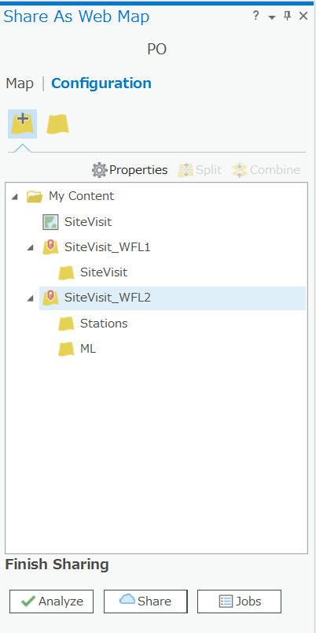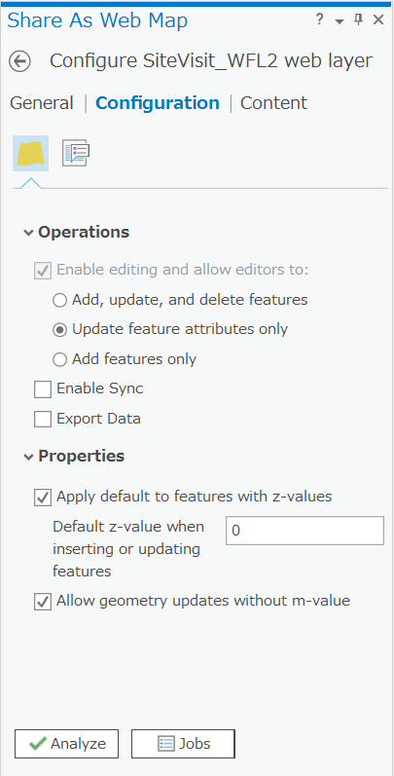 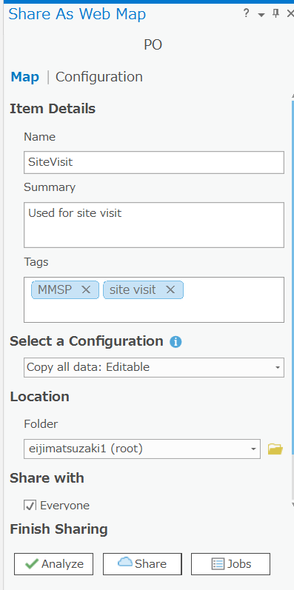

1. Make sure (above) to split a layer (here, SiteVisit_WFL2) with feature classes that do NOT want it to be used for data entry in Collector for ArcGIS (here, “Stations” and “ML”).
2. Highlight SiteVisit_WFL2, click “Properties”, and check “Update feature attributes only”
3. Finally, make sure to choose “Copy all data: Editable” under Select a Configuration. If you do not choose this, you would not be able to add points in the Collector for ArcGIS app.